TIME SERIES FORECASTING
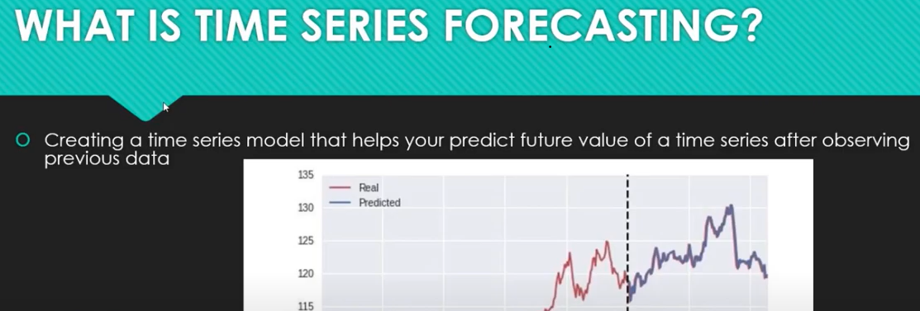
Before you build any time series model you need to check what is stationary –
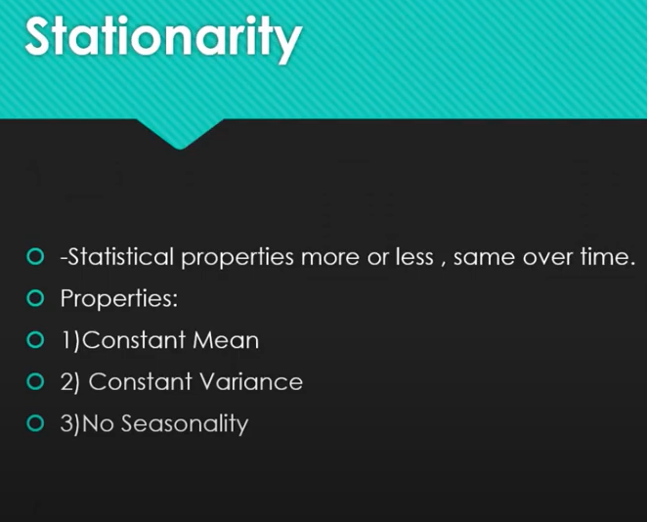
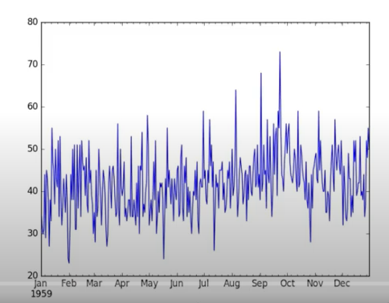
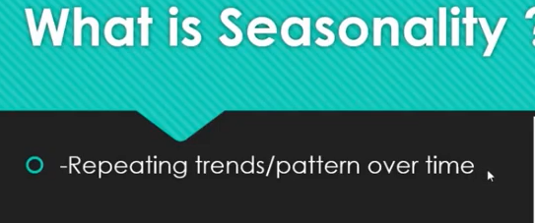
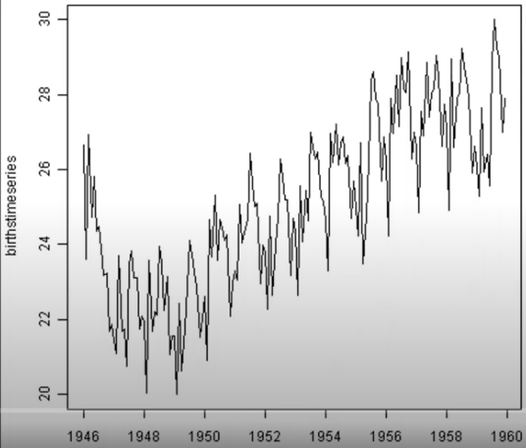
Hear I have 9 graph lets understand which one is time series or not
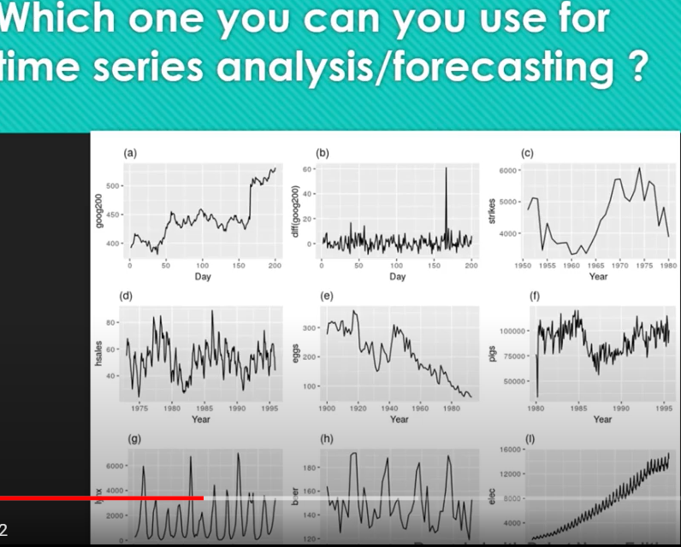
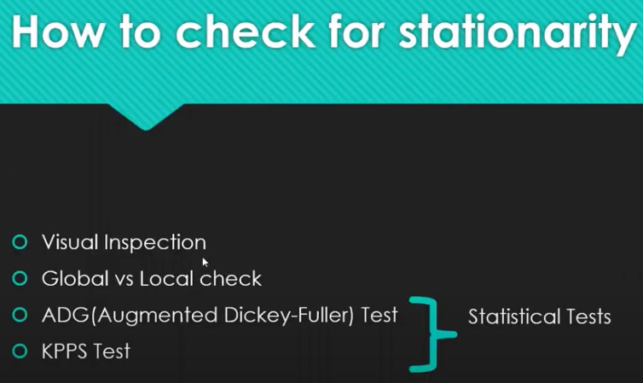
- Visual inspection – to find out a particular plot is stationary or not
- Do a global vs local check – basically we find the mean of the entire time series and find the mean of local periods and see weather it is matching or not. If the mean and variance will varies then it is stationary
- once you identified if the time series is not stationary you need to figure out how to convert to stationary so that we can use time series model for that
- many methods to check for converting non stationary to stationary
Differencing –
Basically subtracting time series values with time with previous time period . if you check the below graph by the differencing I am getting constant mean
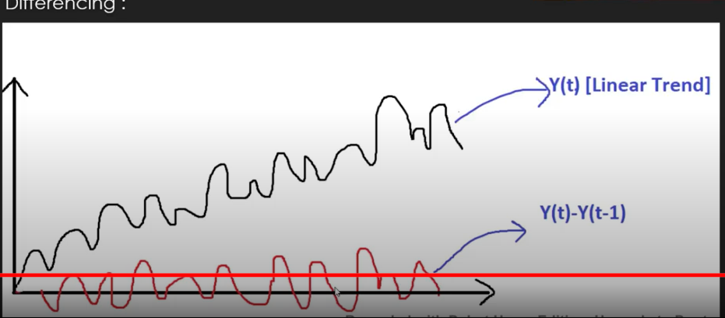
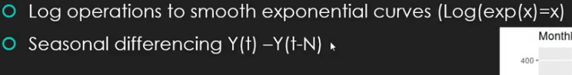
Y(T) = Y(t-N)
Subtracting the value from previous time and N refer to time cycle where the patters are repeating
- As per the below graph 1st graph the electricity is expontial growing
- 2nd graph periodic pattern is repeating (hear we do seasonal differentiating
- 3rd graph is stationary because the mean is 0
- 4th graph is complete stationary and there is no periodic pattern

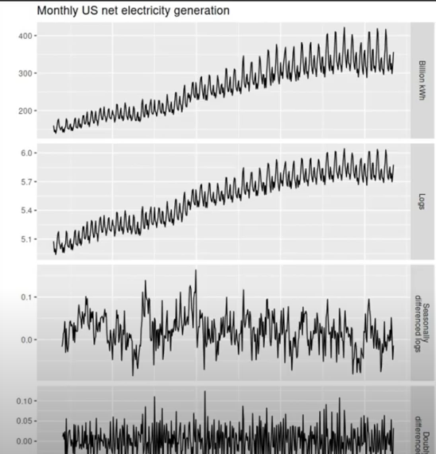
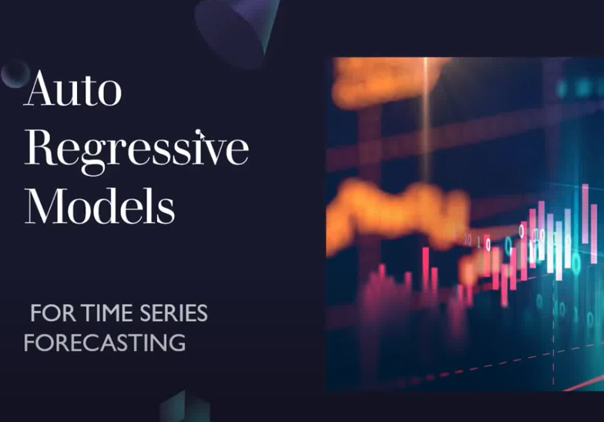
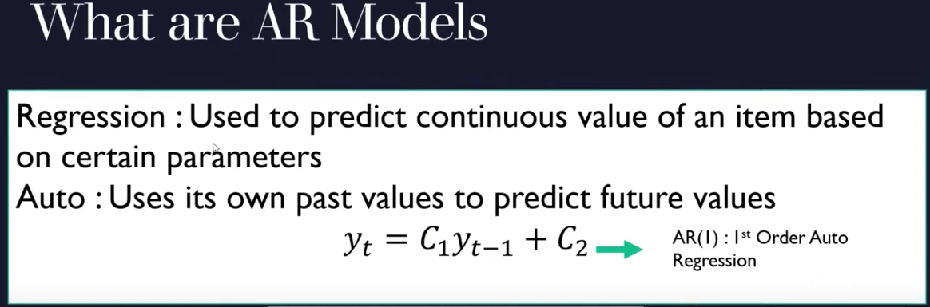
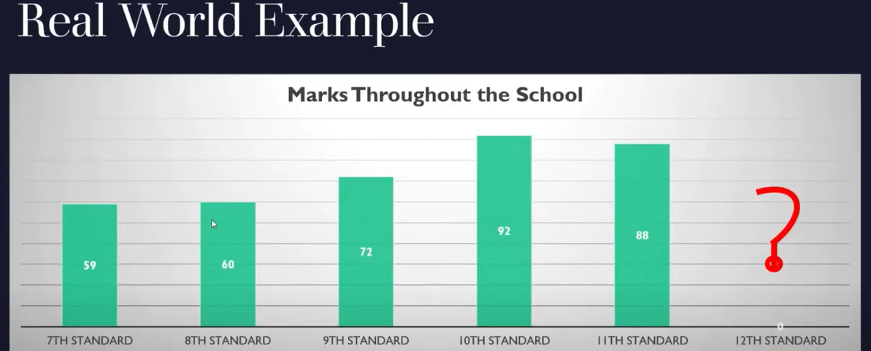

Above graph is the marks of the student from 7th to 11th standard & need to predict what mark he is going to get on 12th grade?
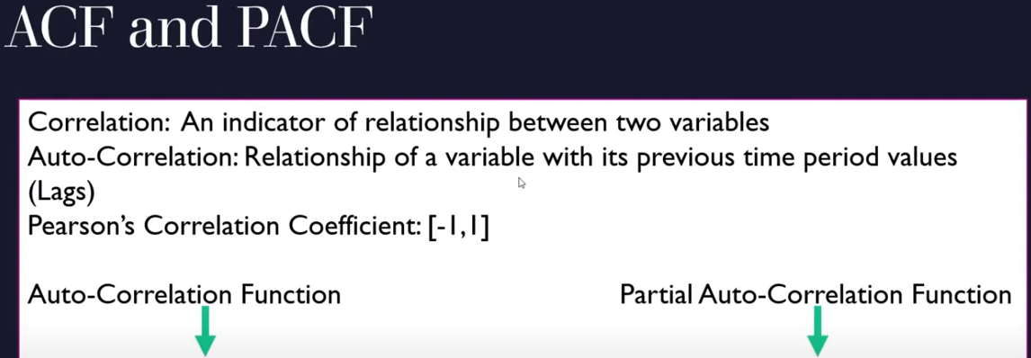
AUTO CORELATION FUNCTION Direct and indirect effect of values in previous time lags with the current time period
PARTIAL AUTO CORELATION FUNCTION Only direct effect of values in previous time lags
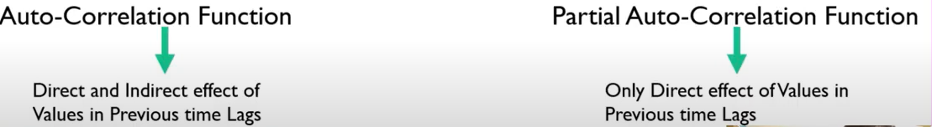
Direct effect – score considered only for previous time
Indirect effect – score consider for 8th grade, 9th grade, 10th grade as well
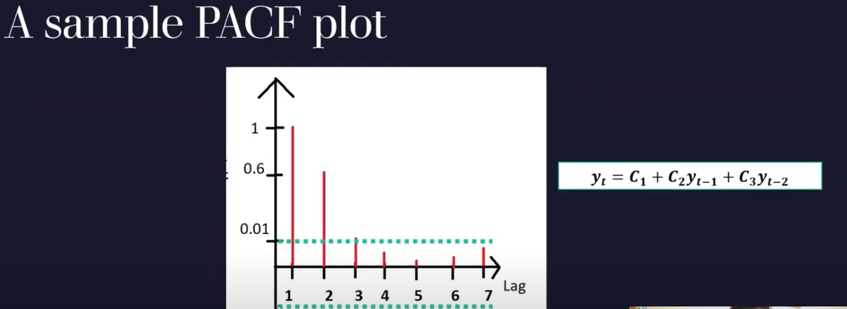
x-axis 1 – means (t-1) ||| x-axis 2 – means (t-2)
I hope everyone has clear understanding between co relation
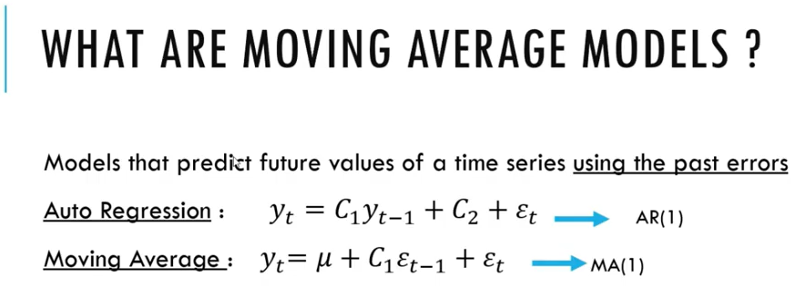
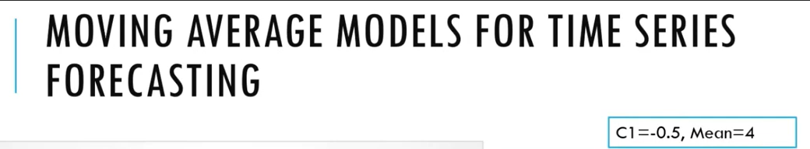
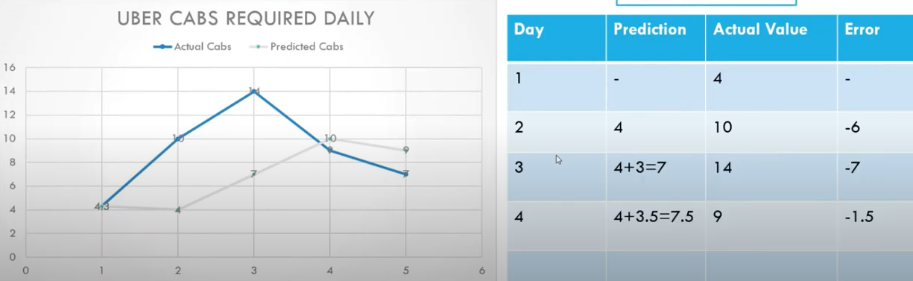
- Being a data scientist, you need to prediction what is number of cabs required for next day
- Day1 actual & predicted = 4 (No prediction hence no error)
- Both lines are moving together that’s why we called as moving average
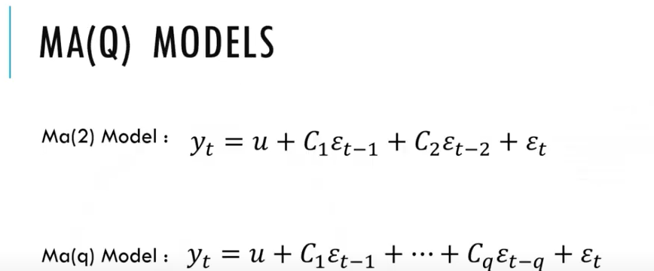

AR model we will use both ACF & PACF
MA model we will use only ACF function

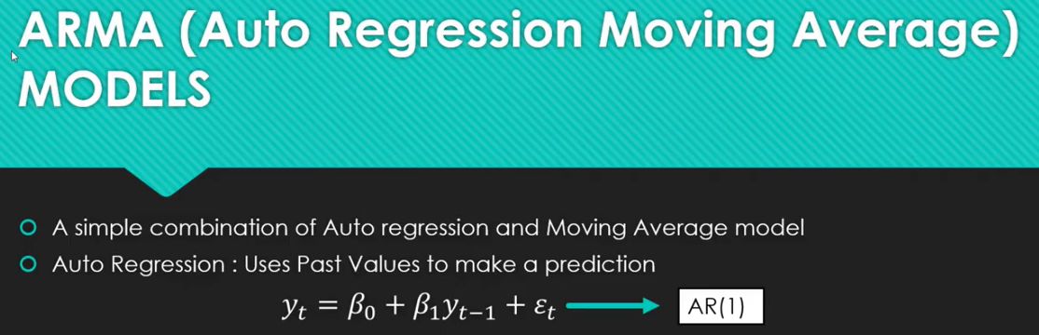
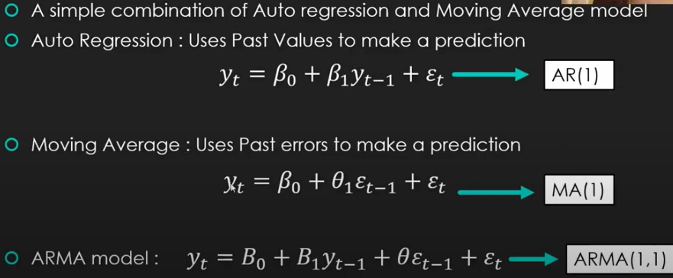
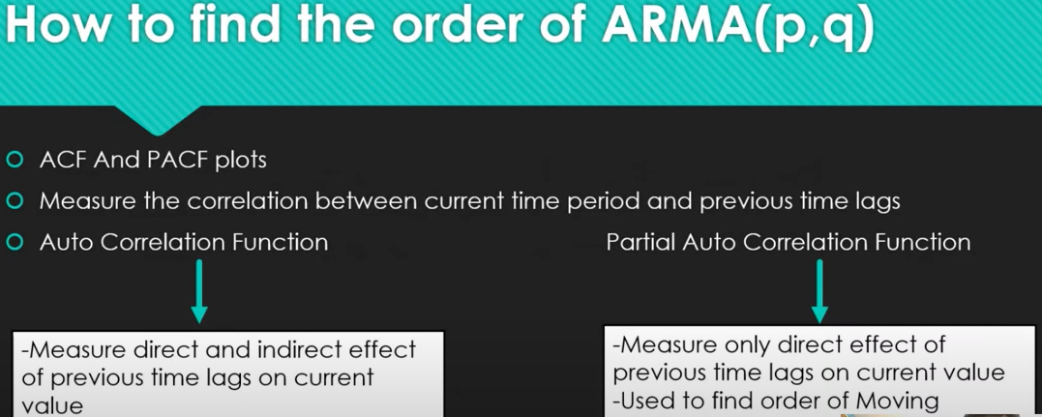
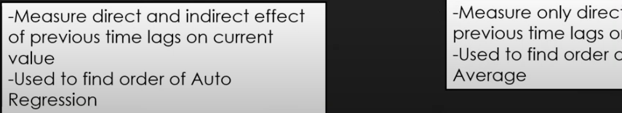
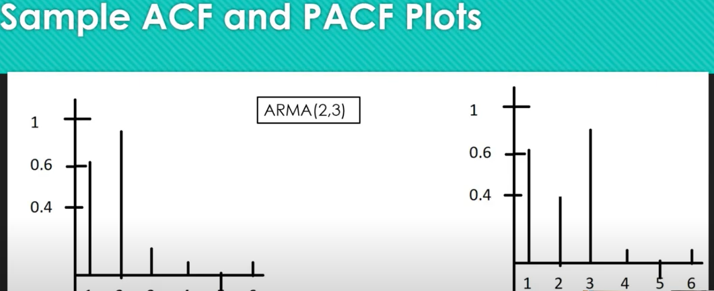
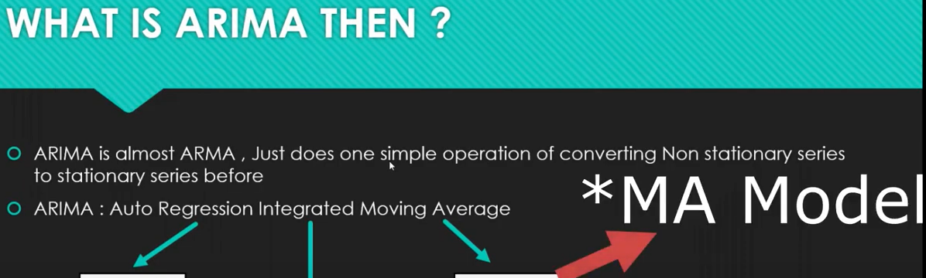
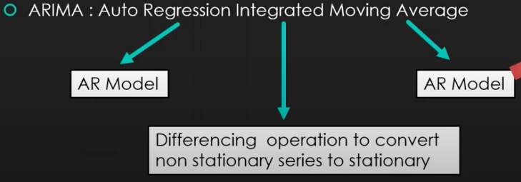
White noise if you find in time series then you abandon the project
Characteristic of white noise are – constant mean, constant variance, no auto corelation
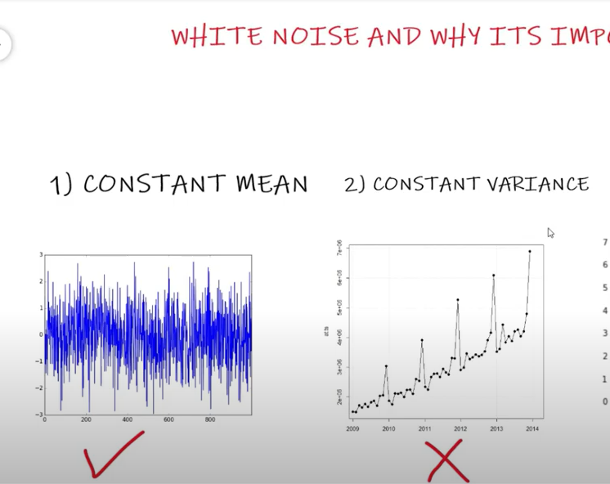
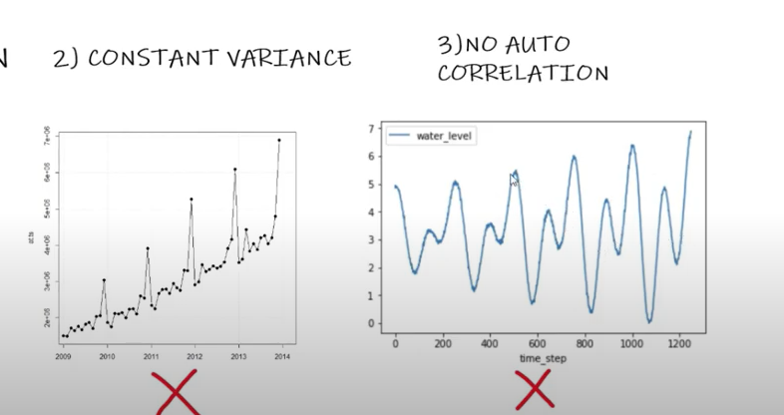
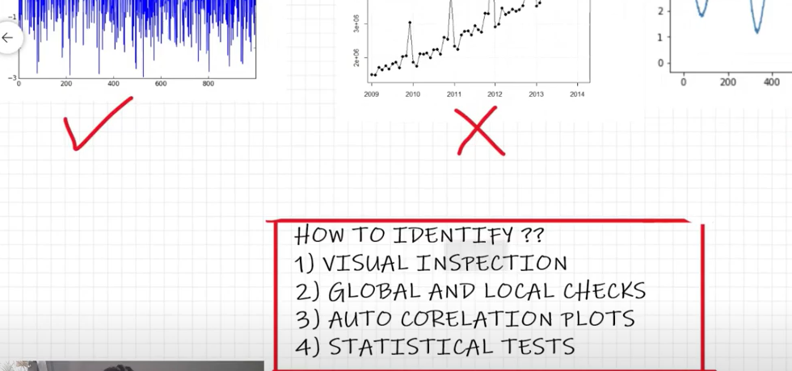
Take a mean of sample which is called as global check
Local check means you need to take the mean of periodically

